All CSVs are now covered, and the invoice file reveals deliberate messy enterprise inputs: locale-formatted amounts, mixed date formats, repeated invoices across channels, blank PO references, invoice bank accounts, blocked vendors, and currency mismatches. I’m going to compute the exact scenario inventory and join quality next, because the project should distinguish seeded business exceptions from data-quality failures and from unsupported assumptions.
The key ambiguity is now clear: invoices contain a PO number but no PO line number, while receipts and tolerances are line-level. I’m quantifying which invoices can be linked
unambiguously by vendor, PO, and amount, and which must be routed as “insufficient evidence” rather than letting an AI guess the line.
The analysis completed and produced a compact exception inventory; I’m reading that result now, then I’ll translate it into operator prompts, orchestration rules, demo cases, research answers, missing artifacts, and a two-day execution schedule.
Read content.txt
The computed inventory is strong enough to expose several hidden design traps: 148 of 152 invoices can be linked uniquely to a PO line by amount, four cannot; two of those are exactly 35% price uplifts, while two point to the wrong PO but can be recovered from
vendor-plus-amount evidence. I’m doing one final precedence-based classification so the guide includes defensible demo records, approval owners, and “do not guess” outcomes.
The final classification is ready. I’m extracting only the resulting counts and representative records now; after that I’ll give you the complete build sequence and a document-ready structure, while noting the current read-only mode prevents me from writing the TXT/DOCX directly.
I accessed all 10 CSV files and did not access any XLSX file. The CSV dataset contains 152 invoices, 60 PO headers, 112 PO lines, 53 goods receipts, 56 vendor rows, 10 GL accounts, five approval bands, and 90 condition records.

What The Data Proves
- The intended solution is an AP invoice validation and exception-routing orchestrator, not a general finance chatbot.
- Seeded scenarios include duplicate invoices, bank-detail changes, partial receipts, non-PO invoices, price variance, blocked vendors, wrong currency, and missing PO references.
- 148 of 152 invoices can be associated uniquely with a PO line by amount.

- Two invoices have an exact 35% uplift: 5110000005 and 5110000028.
- Four invoices have blank PO references, but each has one plausible PO candidate based on vendor and amount.
- Two exact cross-channel duplicate groups exist: INV889740 and INV463733.
- Two invoice bank accounts differ from the vendor master: 5110000017 and 5110000050.
- Three invoices involve blocked vendors.
- Two invoices use currency different from their referenced PO.
- Two PO lines have partial receipts: 46200001/10 received 40 of 67; 46200002/20 received 225 of 375.
- Fifty-nine PO lines have no goods receipt.
- All 152 invoice GL_CODE values are blank.
- Every PO header total differs from the sum of its PO lines. Do not use EKKO.NETWR as trusted matching evidence.
- KONP_Conditions.csv cannot be reliably joined to a PO because its KNUMH is not present in the PO tables.

Critical Limitation
The dataset has invoice headers but no invoice-line table such as SAP RSEG. Therefore, you cannot honestly claim complete three-way matching. A real three-way match requires:
Invoice line ↔ PO line ↔ GR line
Your prototype can infer a candidate PO line from amount, but must label that
result inferred, not confirmed. On the hidden dataset, amount alone may not identify a unique line.

Build From Start To End
- Name the solution AP Exception Control Tower or Invoice Assurance Orchestrator.
- Define the user as an AP analyst who reviews parked invoices before approval.
- Use RBKP_Invoice.csv as the trigger source.
- Preserve every raw value before normalization.

- Normalize amounts such as 327845,70, 53,431.20, and 1445359,95.
- Normalize the three supplied date formats, but return UNPARSEABLE rather than guessing ambiguous dates.
- Run duplicate detection before expensive downstream checks.
- Validate the vendor, posting block, deletion status, payment terms, currency, and bank evidence.
- Never accept bank details from an invoice as authorization to change the vendor master.
- Validate the PO exists and that PO vendor and invoice vendor agree.
- Validate invoice and PO currency; hold mismatches because no exchange-rate policy is supplied.
- Resolve the invoice to a PO line only when there is exactly one supported candidate.
- Compare ordered quantity with cumulative goods receipt quantity.
- Treat no receipt, partial receipt, and over-receipt as different outcomes.
- Calculate amount variance, but do not invent an allowed price tolerance.
- Route missing-PO invoices to PO recovery and non-PO coding.
- Require a GL account and cost centre for a genuine non-PO invoice.
- Route approval using the DOA matrix.
- Generate one evidence-based decision: CLEAR, REVIEW, HOLD, or BLOCK.
- Produce an audit record containing raw evidence, normalized evidence, rules triggered, owner, and next action.

Recommended Operators
  - Normalization Operator: Standardizes amount/date formats and preserves raw values.
  - Duplicate Operator: Uses normalized vendor plus invoice reference as the primary key; channel is not part of uniqueness.
  - Vendor and Bank Operator: Checks SPERR, LOEVM, master bank, invoice bank, and recent bank changes.

  - PO Integrity Operator: Checks PO existence, vendor, company, currency, and status.
  - Line Resolution Operator: Returns CONFIRMED, INFERRED, AMBIGUOUS, or NOT_FOUND.
  - Receipt Operator: Compares PO quantity and cumulative signed receipt quantity.
  - Non-PO Coding Operator: Suggests valid GL choices but requires human confirmation.
  - DOA Routing Operator: Selects the approver based on amount and cost centre.
  - Decision Operator: Consolidates evidence without replacing specialist results.
  - Orchestrator: Calls operators in risk-first order and stops immediately on critical controls.

Orchestrator Priority
  - ​

  - ​

  - ​

  - ​
Use this precedence: duplicate, bank mismatch, blocked vendor, vendor/PO mismatch, currency mismatch, missing PO, missing/partial receipt, amount variance, approval routing. A high-severity failure must not be diluted by later successful checks.

Good Demo Records
  - Clean case: 5110000004, amount MYR 53,431.20, Manager approval.
  - Partial receipt: 5110000087, PO 46200001, line 10.
  - Cross-channel duplicate: 5190000003 duplicates 5110000003.
  - Bank mismatch: 5110000017.
  - Blocked vendor: 5110000105.
  - Currency mismatch: 5110000044.
  - Missing PO reference with inferred candidate: 5110000007.
  - Price variance: 5110000005, MYR 632,367.11 versus line value MYR 468,420.08.

Research Answers
  - Duplicate policy: Exact normalized vendor plus invoice number is a strong block. Amount/date/PO similarity should produce review, not automatic rejection.
  - Bank policy: Invoice bank changes should always be held and independently verified. Both supplied bank exceptions also show suspicious control context.
  - Receipt policy: No receipt normally means hold for goods invoices. Service invoices require service-entry data, which is absent.
  - Tolerance policy: UEBTO and UNTTO are delivery quantity tolerances, not a
defensible price-tolerance policy. Research the organization’s SAP invoice tolerance configuration.
  - Approval policy: The current bands leave decimal gaps between 5,000 and 5,001, etc. Use “highest MIN_AMT not exceeding amount” or fix the boundaries.
  - Hidden-set strategy: Never hardcode BELNR, XBLNR, vendor, PO, or known exception rows. Prompt using field meanings and rules.

What You Are Lacking
  - Invoice line quantity, unit price, PO item reference, and material description.
  - Official price-tolerance configuration.
  - Tax rates and tax-validation rules.
  - Exchange rates and foreign-currency policy.
  - Mapping from KONP conditions to PO lines.
  - Service-entry sheets and service-invoice rules.
  - Credit memo and GR reversal examples.
  - Genuine non-PO invoices with populated GL/cost-centre expectations.
  - Ground-truth expected decisions for testing.
  - Approval outcomes, escalation SLAs, and notification channels.
  - Invoice documents for demonstrating extraction.
  - Exact official judging weights and submission requirements in readable form.

Accountable payable – Pay the vendor money. (the one 拿货的人)
- Then also the additional like the electricity bill

Vendor master = the company that I have to pay them(e.g. Raw material companies that I obtain the raw material from them, Air Selangor for water bill, Transporter companies that they help us to transfer the materials)
PO(Purchase Order) header
Quotation -> PO -> Invoice -> Goods received -> Payment -> Receipt
Quotation(From vendor on price) (Official quote der price, my charge will be how much) PO(Issued by buyer/customer)
Invoice + Goods receipts (Received the goods) → (Cuz usually big companies wont have the receipt cuz too long, only invoice, invoice macam the receipt)
Make payment

Account receivable= The money keep in. 2 invoice duplicate rows, then.
(Catch mistmatches on Invoices, POs

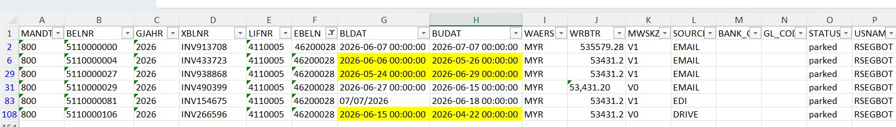

These are common SAP Purchase Order (PO) fields, mostly from the EKKO (Purchasing Document Header) table.

Field Meaning Explanation
SAP client number. Used to separate different

MANDT Client

EBELN Purchasing
environments or business units within the same SAP system (e.g., 100, 200, 800).
The unique Purchase Order (PO) number. Example:

Document Number 4500012345.
BUKRS Company Code The legal entity or company responsible for the purchase.
Example: 1000, MY01.

BSART
Purchasing
Document Type
Defines the type of purchasing document. Examples: NB = Standard PO, FO = Framework Order, UB = Stock
Transport Order.

LIFNR Vendor Account
Number

Purchasing
The supplier/vendor from whom the goods or services are purchased.
The organizational unit responsible for procurement

EKORG
Organization
activities. Example: Malaysia Purchasing, Global Purchasing.

Field Meaning Explanation
EKGRP Purchasing Group The buyer or team responsible for managing the purchase
order.
WAERS Currency Key Currency used in the PO. Examples: MYR, USD, EUR, JPY.
Defines how and when payment should be made.

ZTERM Payment Terms

Changed On /
Example: Net 30 days, Cash on Delivery, 2% discount if paid within 10 days.
The date when the purchase document was last created

AEDAT
Created On Date
or updated (depending on context). Often represents the PO creation date.

ERNAM Created By SAP user ID of the person who created the purchase order.
PROCSTAT Processing Status Indicates the current processing status of the purchase
order (e.g., Created, Released, Completed, In Process).
WKURS Exchange Rate Exchange rate used if the PO currency differs from the
company code currency. Example: 1 USD = 4.25 MYR.
The date from which pricing or conditions become

KDATB Valid-From Date
effective. Mainly used with contracts or scheduling agreements.

KDATE Valid-To Date The expiry date until which the pricing or conditions
remain valid.
The total value of the purchase order excluding taxes

NETWR Net Order Value

Example Purchase Order Field Example
MANDT 100
EBELN 4500012345
(unless configured otherwise), expressed in the PO currency.

Field Example
BUKRS MY01
BSART NB
LIFNR 10000045
EKORG P100
EKGRP A01
WAERS MYR
ZTERM 0001 (Net 30 Days)
AEDAT 2026-07-18
ERNAM CHUAYJ
PROCSTAT Released

WKURS | 1.0000
KDATB | 2026-07-18
KDATE | 2026-12-31
NETWR | 25,800.00

In simple terms
Think of a Purchase Order as an online shopping order for a company:
- EBELN → Order Number
- LIFNR → Seller/Supplier
- BUKRS → Which company is buying
- EKORG → Purchasing department
- EKGRP → Buyer responsible
- BSART → Type of order
- WAERS → Currency

- NETWR → Total order amount
- ZTERM → When payment is due
- ERNAM → Who created the order
- AEDAT → When it was created/updated
- PROCSTAT → Current status
- WKURS → Exchange rate (if foreign currency)
- KDATB / KDATE → Validity period for the order or pricing
- MANDT → SAP client/environment
These fields are among the most commonly used header-level attributes for Purchase Orders in SAP ERP (ECC and S/4HANA).

Detect what:
Operator 1:
Invoice attachment via email, identify the email address(
Orchestator first job, email comes in thru Outlook, once realized got attachment, realize there is an invoice there, extract that attachment, and dump into processing in OneDrive. (First duty) → OCR to detect the PO number AND invoice number.

[Found, then confidence score for the invoice(in invoice there is a PO number)]
- What if the attachment is a picture of invoice?(can be PDF, of word.docx also) ←
Use OCR, the invoice is belongs.
(IF there is no PO number in the invoice document, this route it as error for human review, If got PO number, then proceed to validation in [somewhere] ).

- Schedule the run for checking in outlook inbox for invoice e.g every 5 mins. Integrate Outlook [Integration 1: Outlook with Operator 1]

Operator 1 dump to ONedrive if success.

Operator 2: The duplicate in invoice(from the SAP ← Onedrive) (Integration 2: Onedrive and SAP, which is the operator 2.)
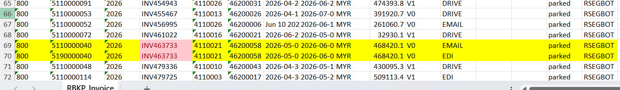

Detect the BLDAT and BUDAT error
- IF BUDAT < BLDAT THEN flag as "Posting Date Earlier Than Invoice Date"
Under normal SAP business practice, BUDAT (Posting Date) is usually the same as or later than BLDAT (Document Date) because you typically cannot post an invoice before it exists.
dump ready for processing invoice to another one drive folder for next scheduled run.

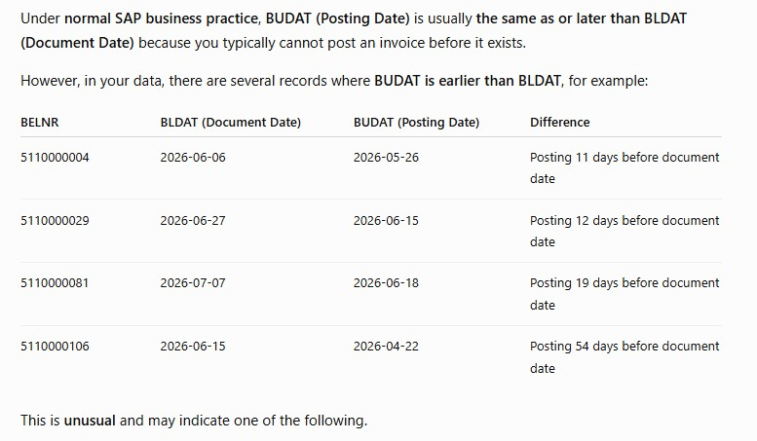

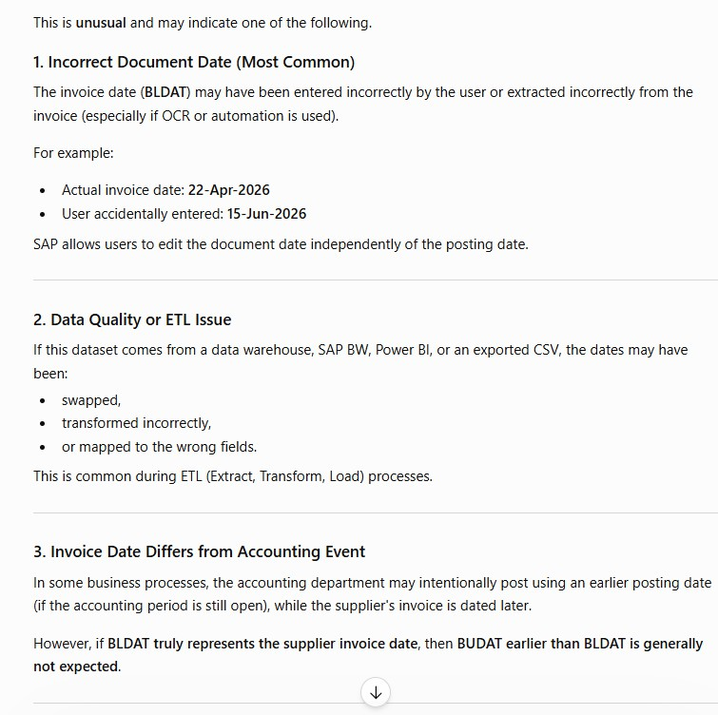

- PO number, not from the 61 rows, then human review. [Cuz scared the PO number, less one number, or more one number….]

Operator 3 – matching invoice material/quantity same as PO quantity and material
PO no & PO item (quantity & material) vs Multiple Invoices with same PO number. Only completed all goods receipts material/qty pay proceed with payment.
PO item
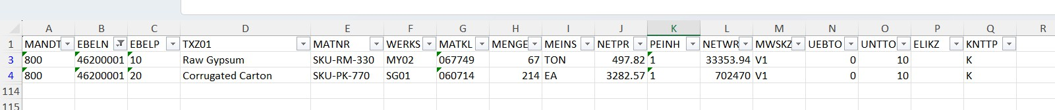

Goods Receipt
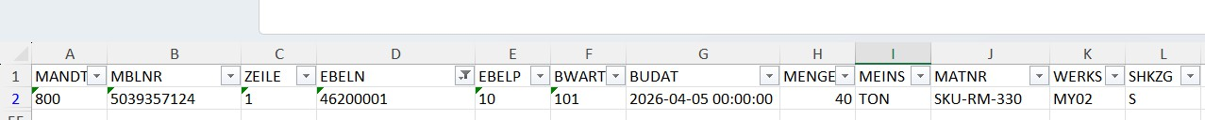
Invoice
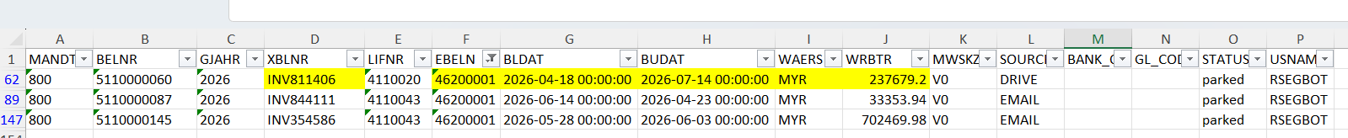
For above Invoice, proceed for human review because there is additional item in Invoice number but not in original PO item

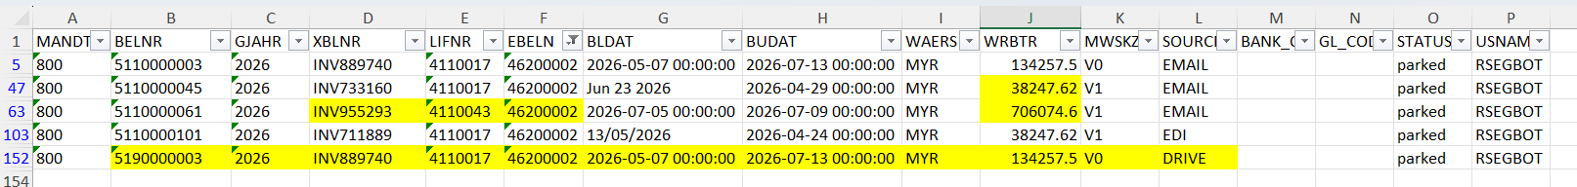
(So for the BUDAT that is earlier than the BLDAT, human review)

(Then for the quantity, u only pay for full quantity right, checking)
3-way matching(At Operator 3) done already, then continue with the next step by ChatGPT……

(Along the 3 operators, got the human review got the error)

Then should be good already, proceed the payment.

So I may need you to make changes of my operators form this orchestrators.
So at first, it will receive the invoices through outlook(the invoice could be PDF, word docx o r csv or something else), so use OCR, to make them into CSV, then check, if it is a correct d ocument, so it is the wrong document then do to the human review, like whether or not it is an invoice. But if is the correct document, then proceed to the next step.
Can work parallel, checking duplicate and also checking mismatch, if there is one of the err or mentioned, then human review again(saying got duplicate or the mismatch error, the inv oices and the PO ).
If good, then proceed to the next step, the 3-
way matching, the material and the quantity stuff, from the PO, Invoices and the Goods rec eipt, do the risk score from that.
If the risk score is high not good, send to human reivew, or else right, proceed to the next st ep, which is pay ready.
So under pay ready right, form a approved metric workflow for payment. Lets say Manager -
> 10k, then the senior manager -> 20k, then CEO -> 1 Million and so on.
Then after that is the payment to vendor, so if the is bigger than certain amount(lets say Rm 100K), then manual since its a big money, or else, automate it.
What do you think?

1. Human Review(tell explicitly the error → Wrong doc, check duplicate/mismatch)
- Invoice 20000

Outlook
To: jaya.das@company.com Cc: chuayujien@outlook.com

[pay-ready]

